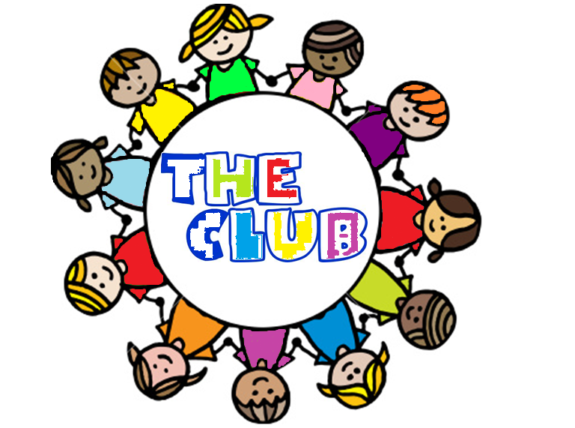
The Club Membership Form
Name of Child (in full) | Date of Birth
School | Class
Name of Parents / Guardians
Address
 | Postcode
Daytime Number | Home Phone
Email | Mobile
Emergency Contact Name and Number
(If we are unable to reach you on the above numbers)
Collection – Please note below the name(s) of the person(s) who may collect your child from The Club. (If different from above).
Name | Relationship to Child
Name | Relationship to Child
Name | Relationship to Child
Password required by any persons collecting your child
Doctors Name | Tel. Number
Does your child have any known medical problems, i.e. asthma, allergies? YES/NO
If YES, please give details and list any regular medication:

Does your child have any special dietary requirements? YES/NO
If YES, please give details:

Does your child have any additional needs? YES/NO
If YES, please give detail:

Please Tick Required Days-
After School Club | Monday | Tuesday | Wednesday | Thursday | Friday
3.00pm – 5.00pm
3.00pm – 6.30pm

For New Starters- What date would you like your child to begin The Club?
Once you have made a regular booking, you will be invoiced shortly before each new term.
Payment is required within 14 days to avoid termination of contract.
You can pay standing order, bank transfer, cheque or cash.

Parental Consent
I give permission for; Delete
First aid to be carried out on my child by a trained first aider/doctor YES/NO
The use of plasters YES/NO
The use of antiseptic spray (minor grazes, stings, burns etc) YES/NO
My child to be photographed during activities at The Club for developmental records. YES/NO

If accepted, this membership Application forms the basis of your contract with The Club.
Please read the information contained within ‘The Clubs parent Guide’

Signed…………………………………………………………………….. Dated………………………………………………
All information provided on this form will remain strictly confidential.

